

**BOSTON | SEATTLE**

**187 Ballardvale St. Suite A195 ●Wilmington, MA 01887● Ph: +1.978.694.1008**

[**getsecure@securityinnovation.com**](mailto:getsecure@securityinnovation.com)**●** [**www.securityinnovation.com**](http://www.securityinnovation.com)

|  |  |
| --- | --- |
| **Document name:** | Using Apktool – APK to Smali |
| **Author(s):** | Dinesh Shetty |



Using Apktool – APK to Smali

# Contact Information

### Technical Contact

Dinesh Shetty

Senior Security Engineer

Email: [dinezh.shetty@gmail.com](mailto:dinezh.shetty@gmail.com)

# Test Configuration

The following is required to verify this issue:

* Download the latest version of the Android-InsecureBankv2 apk from <https://github.com/dineshshetty/Android-InsecureBankv2>
* Download Android SDK from <http://developer.android.com/sdk/index.html>
* Download the latest version of apktool from <http://ibotpeaches.github.io/Apktool/>
  + The installation guide can be found at <http://ibotpeaches.github.io/Apktool/install/>
* Download the latest version of SignApk from <https://github.com/appium/sign>

# Test Steps

1. With the Android Emulator running, copy the InsecureBankv2.apk file to the “platform-tools” folder in the Android SDK and then use the below command to push the downloaded Android-InsecureBankv2 application to the emulator.

./adb install InsecureBankv2.apk

1. Launch the installed InsecureBank application on the Emulator. Following screenshot shows the default screen available to a normal user after login.

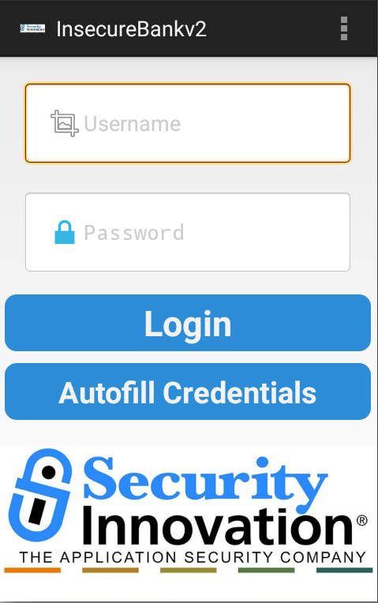

1. Copy the InsecureBankv2.apk into the “apktool” folder and enter the below command to decompile the application:

./apktool d InsecureBankv2.apk

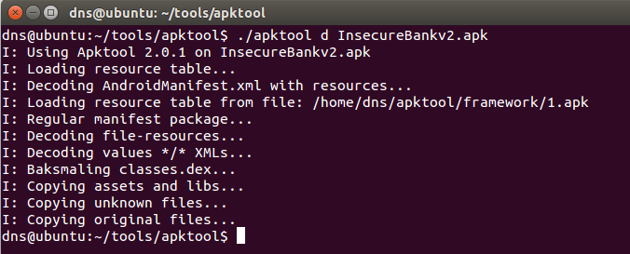

1. The smali code is now stored in the folder named “smali” inside InsecureBankv2.

